【获奖者李洪芬】医者仁心 国粹荣光——国际中医肿瘤研究中心主任研究员李洪芬获2025大本钟奖之卓越华人成就奖
[ Li Hongfen received the 2025 Big Ben Award ]
A doctor's benevolence brings glory to the nations –
Dr Li Hongfen, director of International Chinese Medicine Cancer Research Center, oncologist and research fellow .
She has been honoured with the 2025 Big Ben Award for Outstanding Cancer Research Achievement

The Big Ben Awards were prepared in the late 20th and early 21st centuries. Thanks to the efforts of its Chinese founders and other expatriates, the first selection was held in 2008. It is an authoritative award for outstanding individuals, excellent brand cities/companies, and other aspects worldwide. It also bears witness to the continuous development of the Chinese people and Chinese civilization, alongside those of other nations around the world.
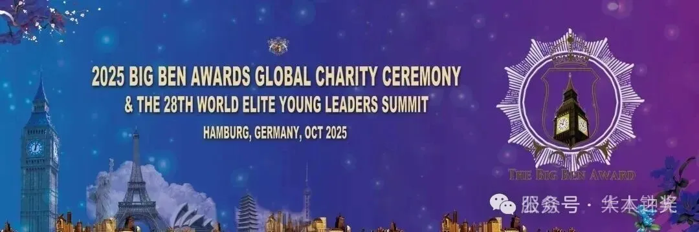
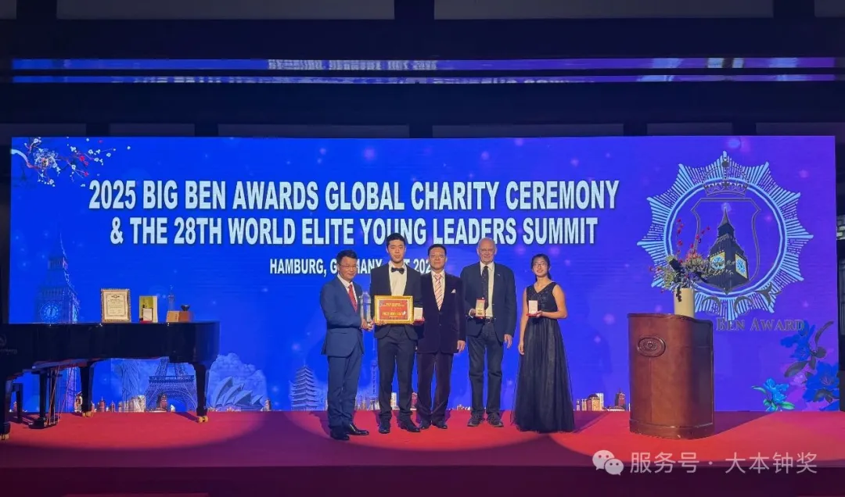
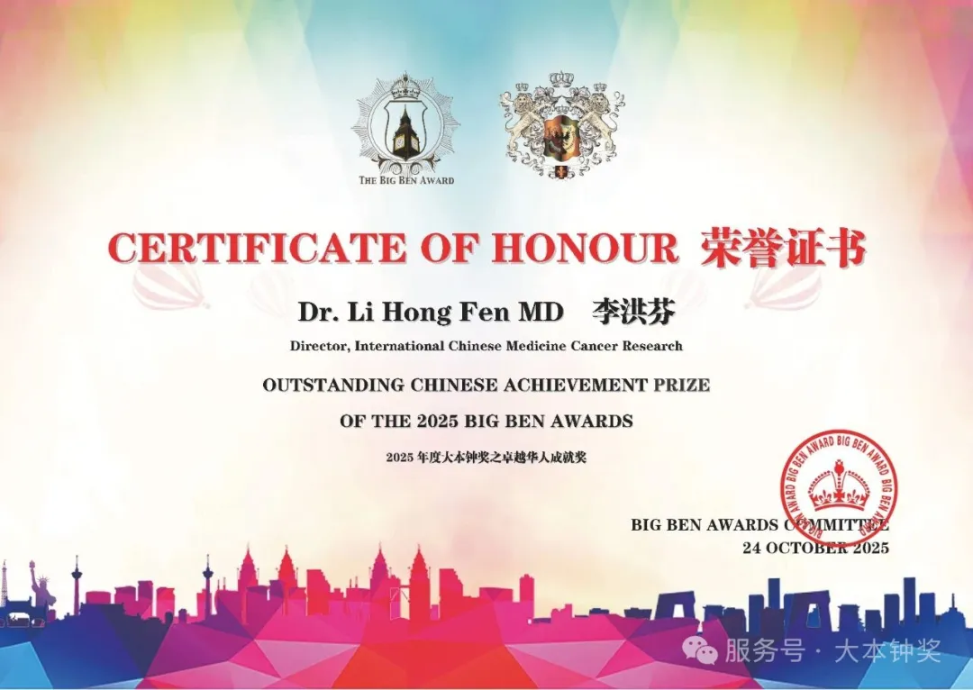
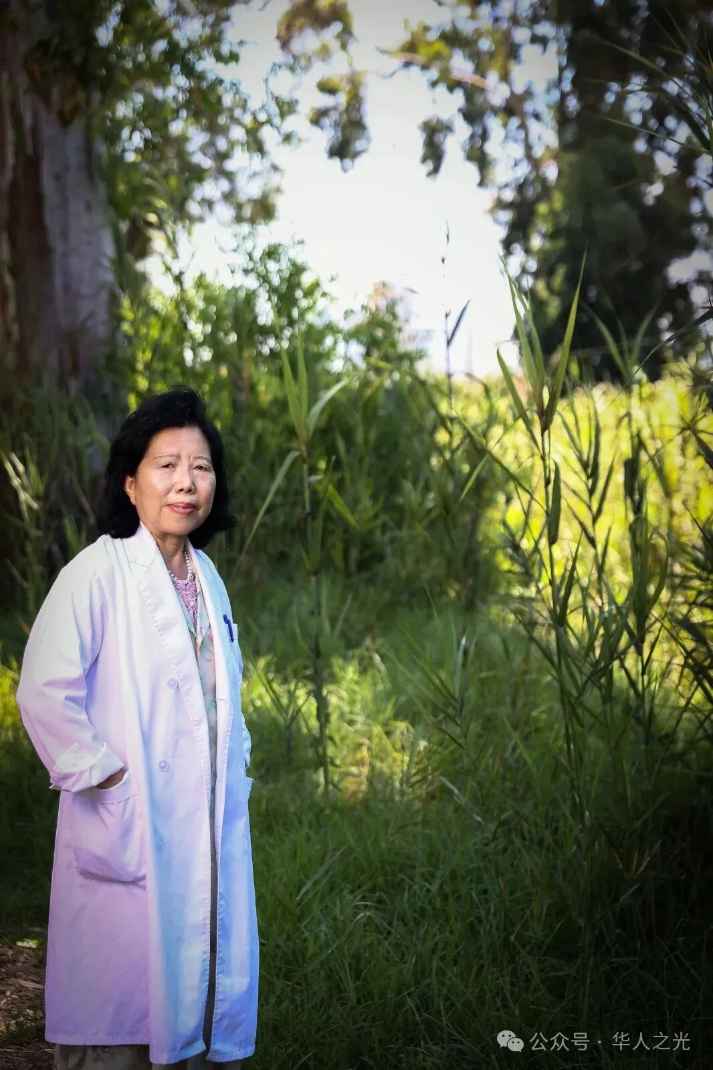
2025 Big Ben Award for Outstanding cancer research Achievement: Li Hongfen (direct International Chinese Medicine Cancer Research Center Israel and UK)

Li Hongfen was born into a 5 generational doctor’s family in Cangzhou, Hebei Province, China. With over 50 years of medical practice, she has traveled between China, Israel, and the UK, dedicatedly serving thousands of thousands of cancer patients worldwide, bringing them hope.

Her great-grandfather, a dedicated doctor , served as a role model for young Li Hongfen. The medical books on her shelf became her first textbooks, and at the age of 18, she resolutely chose to study medicine. Seven years of medical school and 13 years as a lecturer in Western medicine laid a solid theoretical foundation for her medical career. In her teaching, she strives to ensure her students master the most solid theoretical and experimental foundations of Western medicine.
During the five years she worked in the Department of Western Medicine at Peking Union Medical College Hospital, the basic theories she mastered were enriched with various vivid clinical examples and factual cases of difficult and complicated diseases. Soon, Li Hongfen was able to independently respond to and correctly handle emergency patients, and gradually gained the trust and affirmation of patients. Patients regarded her as a close family member.
Although Western medicine is constantly innovating and effective, it also has significant side effects. In the process of finding ways to reduce the impact of these side effects, her great-grandfather's important cases enlightened her: it turns out that the "key to hope" lies in Traditional Chinese Medicine! Thus, she started to research a combination of conventional and Chinese medicine.
During her time studying and practicing medicine in China, Li Hongfen published over 20 scientific papers and received grants for over 10 national and Beijing-level projects. The modernization of Traditional Chinese Medicine is inseparable from definitive data verification. It was precisely because of these outstanding achievements that the Ministry of Health (now the National Health Commission), at the invitation of the Israeli Ministry of Health, dispatched outstanding Chinese medical personnel to Israel for a medical academic exchange. This was the first medical mission dispatched since the restoration of diplomatic ties between China and Israel, a mission of great responsibility and significance.
In early 1996, Dr. Li Hongfen was invited alone to Israel from Xiyuan Hospital of China Academy of Chinese Medical Sciences, to conduct cancer and asthma research on Chinese medicine. Since then, she has been working hard and meticulously for 30 years, starting from basic experiments, and after confirming the efficacy, she used it in clinical trials, saving countless patients with middle and late stage cancer, and also bringing Chinese friendship to Israel through Chinese medicine.
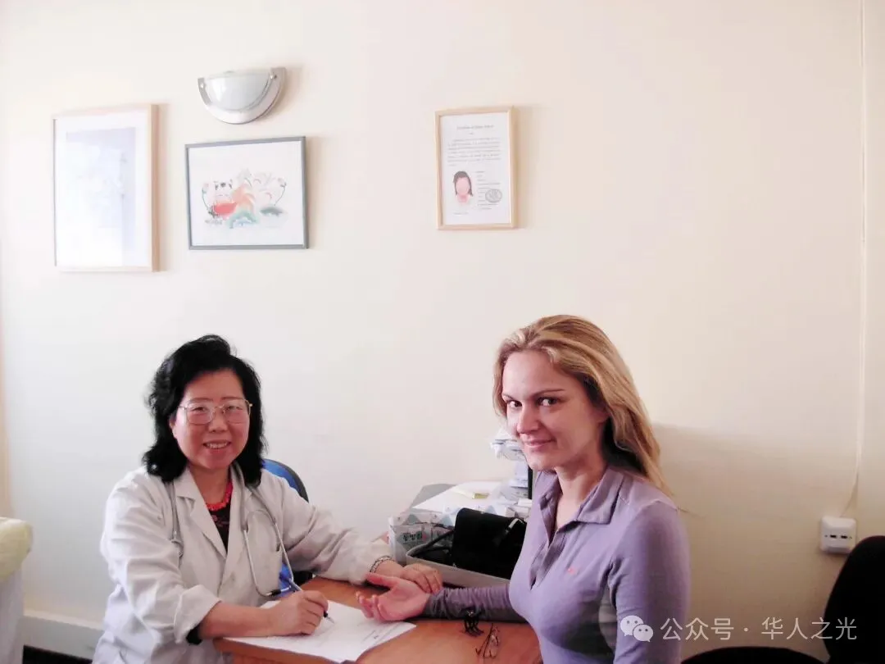

In Israel, she pioneered the design and application of research projects focusing on the treatment of malignant tumors and bronchial asthma using Chinese medicine. These projects were given grants from NIH and approval from the Israeli Ministry of Health. Also established the International Chinese Cancer research center, In which the doctors can make clinical diagnosis, treat patients, and complete basic research and clinical trials for malignant tumors and bronchial asthma. Using the most advanced Western medical experimental methods and techniques at the time, and based on Western theoretical logic, they repeatedly verified the efficacy of medicine.
In 2000, their research findings were recognized by their peers and published in an international journal. Simultaneously, the experimental results further solidified their belief in the remarkable efficacy, mechanism of action, and safety of traditional Chinese medicine, laying a solid foundation for the research center's vigorous development over the past thirty years.
Their research found that ACNO, a traditional Chinese medicine anti-tumor formula, can effectively increase NK cell activity, improve immune system function, and inhibit tumor metastasis (article published in the international SCI journal International Immunopharmacology, 2000, 1:1947-1956, impact factor IF=5.6). In vitro experimental results showed that, without affecting normal cells, ACNO 1 achieved a tumor cell killing rate of up to 85% in vitro. PCCJ, a traditional Chinese medicine asthma preparation, was clinically proven 30 years ago to achieve antitussive and antiasthmatic effects within 24 hours, with an efficacy rate of over 90%. At the same time, basic experimental results further verified the results, showing that it can reduce IgE expression, increase CD4, stabilize mast cells, and inhibit the release of allergy mediators.
Over the course of five years, Dr. Li not only created a "medical miracle" in Israel, but also attracted a constant stream of patients to his clinic for consultations. Many patients with malignant tumors who had been given a "death sentence" after Western medicine treatments began to have their fortunes changed. They went from having no other choice but to being convinced of the efficacy of traditional Chinese medicine and having absolute trust in Dr. Li's medical skills and character. Many patients with malignant tumors have followed Dr. Li for more than ten or even twenty years. Even after their tumors have been cured, they continue to take the medicine to prevent tumor recurrence.
Out of gratitude and eagerness, many Israeli patients and renowned medical colleagues jointly wrote to the Israeli Prime Minister and the Ministry of the Interior. In their letter, they sincerely and enthusiastically explained the reliability of the research results on Chinese Medicine and the astonishing effects experienced by patients after receiving treatment. They wrote that great doctors like Li Hongfen should remain in Israel, and that such amazing medical miracles as Chinese medicine must benefit the Israeli people. Then-Prime Minister Ariel Sharon personally signed the consent form and granted Dr. Li Hongfen the status of a scientist with special contributions, making her a permanent resident of Israel. The Ministry of the Interior officially approved Dr. Li's license as a local clinician, and all medications used in the clinic, including anti-tumor drugs No. 1, 2, 3, 4, and 5, and asthma-relieving medicine, were officially approved for clinical use as legitimate pharmaceutical products. This was an unprecedented and groundbreaking event in a Jewish nation. All of this was made possible by the tireless efforts and unconditional support of all the center's veteran professors and doctors.
Meanwhile, ACNO1 anticancer medicine and PCCJ Asthma medicine have successively obtained patent rights in more than a dozen countries, and Dr. Li is leading her team to climb to higher academic levels.
Dr. Li not only gained the support and endorsement of Israeli patients and colleagues, but her reputation spread far and wide, earning her a high reputation throughout Europe. She became a member of the British Association for Cancer Research (BACR) and the European Association for Cancer Research (EACR), and was invited to give a speech at the Liverpool Oncology Conference, where her medical colleagues learned about the achievements of traditional Chinese medicine in Israel.

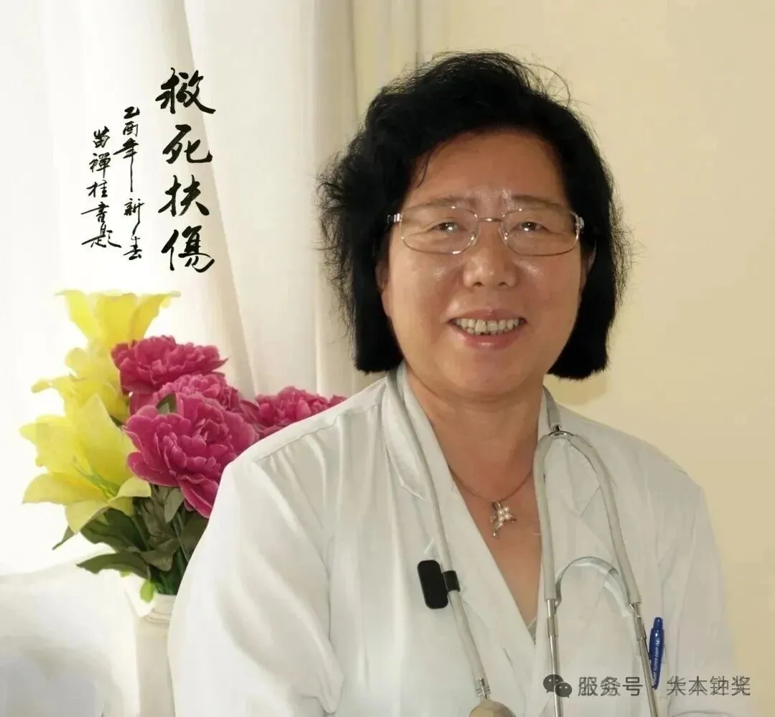

In 2012, Dr. Li Hongfen opened her second cancer research center in the UK to facilitate visits from European patients. Since then, patients following Dr. Li have traveled from Israel to the UK, from China to Serbia, spanning 44 countries worldwide. Dr. Li has treated countless patients with advanced cancer, saving patients with only two weeks to live and children who had been in a coma for eight months due to brain tumors. She says, "Being with patients is my most fulfilling and happiest time. A good doctor should be patient and work tirelessly." Patients affectionately call her "Our Dr. Li."

Many patients in China, especially those with lung and colon cancer, have been using ACNO for over 20 years to treat tumors. Meanwhile, the research findings continue to benefit patients across China. Dr. Li Hongfen has also come to deeply appreciate how the spectrum of human diseases has changed significantly due to the passage of time, environmental shifts, and dietary changes. Malignant tumors have become a major factor threatening human health and affecting lifespan, and this demand for Chinese medicine treatment of tumors is growing not only in Europe and America but also in China. Dr. Li Hongfen says that her mission is becoming increasingly important, from China to Israel to the UK, and then to the rest of the world.
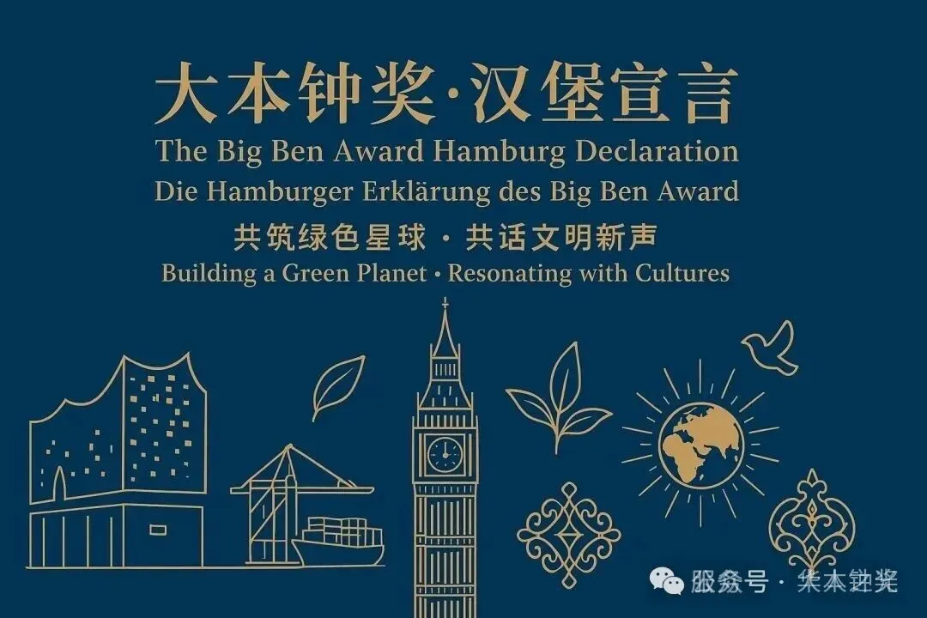

扩展阅读
.中国副部级领导获大本钟奖
- 致敬黄文麟——2024年度大本钟奖终生成就奖获奖者
- 【视频】福建省委原常委黄文麟获大本钟奖终生成就奖的获奖感言
- 【致敬经典 这份荣耀的重量】架起改革的一座丰碑——评中国副部级领导福建省委原常委黄文麟获得大本钟奖终生成就奖的重大意义
【大本钟奖】如何推荐和申请并下载候选人表格
欢迎推荐2025大本钟奖候选人

扫描以上二维码获取大本钟奖赞助手册
大本钟奖赞助手册

扩展阅读

- 中国副部级领导获大本钟奖
- 致敬黄文麟——2024年度大本钟奖终生成就奖获奖者
- 【视频】福建省委原常委黄文麟获大本钟奖终生成就奖的获奖感言
- 【致敬经典 这份荣耀的重量】架起改革的一座丰碑——评中国副部级领导福建省委原常委黄文麟获得大本钟奖终生成就奖的重大意义
【大本钟奖】如何推荐和申请并下载候选人表格
欢迎推荐2025大本钟奖候选人

扫描以上二维码获取大本钟奖赞助手册
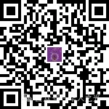

点击以下链接了解


【中国新闻社2023年10月报道】“大本钟奖”十五周年颁奖仪式在伦敦举行
英国王储威尔士亲王发来贺信 大本钟奖15周年全球第一场颁奖仪式暨第26届世界精英青年领袖高峰会在伦敦成功举行
如何参选大本钟奖
大本钟奖候选人要求
大本钟奖推荐表中文版下载
- 大本钟奖颁奖典礼主礼嘉宾克莱弗利升任英国外交部部长
- 中国副部级领导获大本钟奖
- 中国区福建组委会转发《关于申报2024年度大本钟奖之金嘉木奖（中文版）的通知》
- 2025/2026全球华裔小姐先生大赛中国赛区启动
- 欢迎推荐2025大本钟奖候选人
- 【欢迎推荐精英律师】2025年度大本钟奖英国十大杰出华人青年律师候选人
- 【欢迎推荐】2025年度大本钟奖之金钻石奖（美食文化/味觉大赛）候选人、候选机构、候选品牌
- 【欢迎推荐】2025年度大本钟奖英国十大杰出华人青年候选人
- 【欢迎推荐】2025年度大本钟奖全球十大杰出华人留学生
- 【欢迎推荐精英会计师】2025年度大本钟奖英国十大杰出华人青年会计师候选人
- 中国区转发《关于申报2024年度大本钟奖之金嘉木奖（中文版）的通知》
- 2023年度大本钟奖世界旅游目的地排行榜
- 大本钟奖之启明星全球科技标杆大奖部分获奖名单（2009-2023）
- 欢迎推荐大本钟奖各选区杰出精英及杰出华人青年候选人
- 【步骤】如何参选大本钟奖
- 大本钟奖候选人要求
- 大本钟奖提名（推荐）表格中文版下载
- 英国王储威尔士亲王发来贺信 大本钟奖15周年全球第一场颁奖仪式暨第26届世界精英青年领袖高峰会在伦敦成功举行
- 【伦敦地区志愿者招募】大本钟奖十五周年颁奖典礼执行志愿者
- 大本钟奖之希波拉底奖杰出贡献奖部分获奖名单（2009-2014）
- 陈奕迅与大本钟奖
- 欧洲-大西洋小组生命健康委员会
- 【为了以后的每个七夕】英国青联牛郎织女公益计划
- 大本钟奖之金独角兽奖终身成就奖获奖者让-吕克·戈达尔 Jean-Luc Godard（法国）去世
- 2022年度大本钟奖之赫拉特勒斯奖发布 梅西领衔 三中国运动员入选
- 2022年大本钟奖全球十大杰出女性奖（金康乃馨奖）获选名单
- 2022年度大本钟奖中国区慈善公益颁奖仪式
- 【英国伦敦】全球艺术双年展2022
- 【英国伦敦】全球艺术双年展申请报名表格（中文版）
- 五四青年节快乐丨岁月不老，青春不朽！
- 【招募志愿者】2022年度5C峰会【世界精英青年领袖高峰会】【伦敦中国论坛】【大本钟奖杰出留学生颁奖仪式】
- 欢迎推荐大本钟奖候选人
- 张一鸣全红婵刘晓禹艾玛•拉杜卡努吕小军汪顺苏炳添等入选2021年度大本钟奖 同期发布全球十杰华青奖、璀璨未来奖、世界旅游目的地等
- 欢迎推荐本年度英国十大杰出华裔留学生候选人
- 2021年度大本钟奖最受推崇世界旅游目的地排行榜发布
- 大本钟奖之赫拉特勒斯奖 体育之光
- 【伦敦发布】三位中国运动员入选2021年度大本钟奖体育类赫拉特勒斯奖全球奖项
- 【大本钟奖候选人】“黑马”全红婵，不只是天才！
- 大本钟奖之金鸥奖
- 2017年度大本钟奖之神工奖全球十大杰出华裔设计师
- 欢迎您推荐2021年度大本钟奖暨全球杰出精英评选候选人暨第二十届、第二十一届世界精英青年领袖高峰会主旨演讲嘉宾
- 大本钟奖简介（2021年1月制）
- 【视频】央视：大本钟奖慈善公益颁奖典礼（十周年回顾）
- 【视频】英国国务大臣、外交部副部长马克·菲尔德国会议员获颁2018年度大本钟奖并发表获奖感言
- 【视频】方文山荣获2016年度大本钟奖之金独角兽奖音乐类最受推崇作词人的获奖感言
- 【视频】2018年度大本钟奖英国国会全球颁奖典礼赞助商
- 大本钟奖十周年短视频（2018年制作）
- 【全球媒体关注】世界各大主流媒体报道大本钟奖部分记录
- 世界排名第一的阿拉伯语新闻媒体报道大本钟奖（2019年2月）
- 大本钟奖终生成就奖获得者

